Mikhal Roell
Mrs. Sutton
Genius Hour
27 May 2015

Summarize the purpose of your Genius Hour project in 140 characters.

Genius Hour was invented by business practice that Google uses for their developers. They let their developers spend twenty percent of their time at work on developing ideas that have potential to boost the company. Google says it helps bring up productivity. Google idea really worked because some ideas that developer created are a great hit like Gmail, Google talk, and Google news.
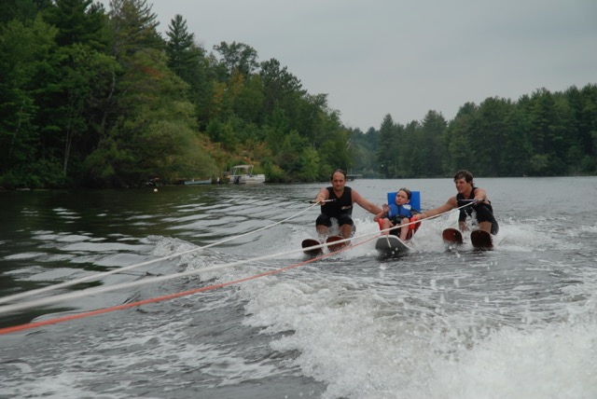
The purpose of Genius Hour in our English class was to help tell people about something we are passionate about. Mrs. Sutton wanted us to get more engaged and motivated with school. Genius Hour was a good way to do it because it lets us share what we are passionate about with our classmates and school. We were allowed to do whatever we wanted to do with some guidelines that we had to follow. Genius Hour is a good way to help us learn to be responsible because we need to keep up with are blog posts and are website. It strays away from traditional teaching ways because lots of students get bored just watching the stand in front of the classroom and teach. This gives a way to do what they want and do it the way they want to. This teaching way I thought that was a great way to get us more in tune with school. I was a way for all students to share something they are passionate about.
Explain the process of your Genius Hour project. Be reflective. Be contemplative. Explain and describe your journey

My first task of my Genius Hour was to come up with an idea that I am really passionate about. I thought long and hard with what I wanted to do and then the idea came to me, waterskiing. I thought more about it and I really just wanted to talk more about a certain topic of waterskiing. The idea I came up with was disabled waterskiing. I currently in a water ski club called the Badwater Ski-ters. We as a club hold a special event each year called disable water skiing. This event is where people from all around us like in Kingsford, Iron Mountain, Norway, and Florence bring family and friends that are disable to our site where we then will take them skiing.
You might be wondering why I choose this specific topic to write about and the reason I choose this topic because I want to get the word out that our club does disabled waterskiing. The past few years that I have been involved in this event have been just amazing and wonderful to be apart of. The joy we bring to these disable people really touches a person. We want them to have some fun and do something they have never done. We want to make it as fun as possible for them and bring happiness to them because they really can never do something like this by themselves. Sometime the disabled water-skier wants to ski in the show and we are all for it. We will have a special part for them in the show where they will ski.
The process that I had to take was not as hard as I thought it was going to be in the first place. I talked to my friend Jim Martin, who is the head of the Ski-ters club. He gave me some pictures of previous years of doing disabled waterskiing. Then I had to do some research, but not much cause I knew a lot about the topic. I got some videos that demonstrate how we do disable waterski. I published these videos on my website, so people could see them. I knew in my head that people would get nervous about it and worry about safety. So to calm their fear I put those videos on my website to show how safe it is. I wanted to be informative and helpful so that people would come out and have a fun time skiing.
If you could do anything different with your Genius Hour project what would you do differently and why? (No less than two full paragraphs.)

Looking back on my Genius Hour I thought that it would be an awesome idea to do this because there are many people out there that are disabled and cannot do much for themselves. I wanted to get the word out that are club does this and that everyone is welcome to come out. We encourage people to try things that they are not comfortable with because after they experience skiing they want to go again and again. My journey through this has been eye opening. I realized that what we do for these people is something that they can never experience in their life time. It brings so much joy to me that I can experience and help out with this event. I love doing this because I know first hand how happy this makes them feel. It also makes me feel good inside that I can do this for these people and help them do something they cannot do by themselves. My journey has been amazing and I hope that the next time we do disabled waterskiing that there will be more people there to experience it.
The intention For Genius Hour is NOT only to learn, but ALSO to share your knowledge with others who can and will benefit from your learning. How did you share your learning? What do you hope the result might be?

The way that I wanted to share my project with the community was writing a post on Facebook to the Badwater Ski-ters site and post my link to my website with the post. I originally wanted to post it on the Badwater Ski-ters website, but the Badwater Ski-ters don’t have a webpage. I was really disappointed when I found out that the Ski-ters didn’t have a webpage. I couldn’t figure out what I was going to do, so I went with the Facebook post. It was easy to use and I know the word would get out. These days more people use Facebook than the internet. I feel that everyone who is disabled can benefit from this because they many never have the chance to ever do anything physical because they cannot.
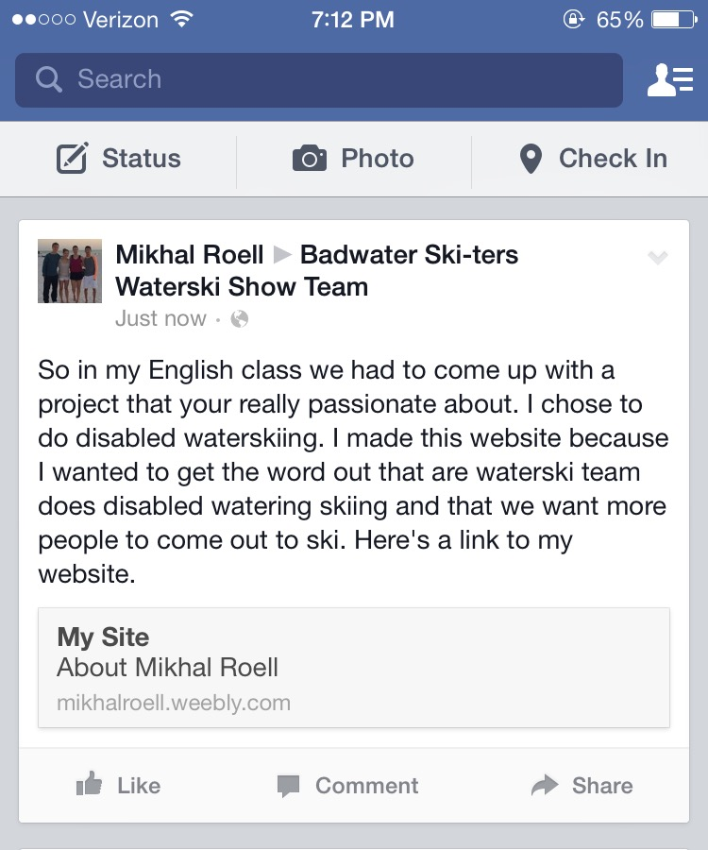
My hopeful result for this project was to get the word out that our club does disabled waterskiing and that everyone is welcome. I want as many people to experience this amazing sport in hopes that they might get more people to come out and try. The joy we bring to the disabled waterskier is something so awesome and amazing. I have noticed through the years that more and more people come because their friends tell them about it. I feel that this website will attract more people to come and try waterskiing.
Reflect on what you did well during this Genius Hour process? Note your successes and accomplishments.
What I did well with my Genius Hour was keeping up with all the blog posts, going research, getting videos of how disabled waterskiing works, and got picture to show my club the Badwater Ski-ters doing disabled waterski. It was not a hard process because I knew what i was doing, so I didn’t have to do as much research on the topic. I had a lot experience doing disable waterskiing, so the fact that I did made my life a lot easier. I talked with my director of ski-ters Jim Martin and he helped me out by finding old picture from when we did disabled waterskiing.
The time that we had in class for Genius Hour I was looking up information and videos that I could put onto my website, so that the person viewing the website might get an insight on how disabled waterskiing works. I tried to make my website user friendly. This basically means that I didn’t make using anything on the website hard to use or hard to find. I felt that if my website was too complicated and too hard find things, then no one would want to look at my website. The time that I took in class I never wasted because I knew that Mrs. Sutton wants the best out of us and I wanted to show her that I put hundred percent into this project. I tried my hardest on my website and in hopes that more people will come out skiing.
If you could do anything different with your Genius Hour project what would you do differently and why?
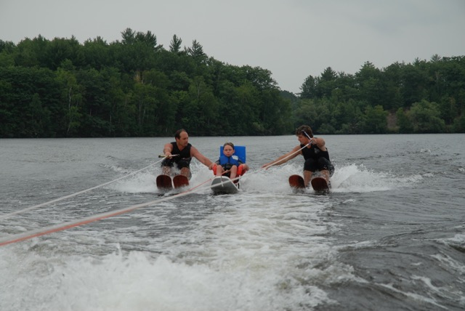
I don’t think that I would have done anything different. The only thing that I would want to do different is that I wanted to talk to more people about it and maybe make a flyer that I could hand out to people. Then main purpose I wanted to do this project was to create a page that people could look at for disabled waterski. I wanted the page to be informative and helpful to people. People have come up to me before and asked how safe disabled waterskiing is and I told them that it is really safe. I believe that this webpage will help show and ease peoples mind on disabled waterskiing. It would’ve been nice if I could of gotten in touch with some disabled homes and talked to them about what my club does.
Telling these disabled homes would’ve been nice because they probably don’t even know about disable waterskiing. I think that if I did that there would be more people that would come to the event. I was thinking about making flyers that I could hang up at some major stores that people could see. The only problem with that is that I don’t have a date for when we are doing disabled waterskiing. All I could of put on the flyer until I got the date was Badwater Ski-ters Adaptive skiing at the Badwater Ski-ters club. I think what I did was good and that hopefully in the future I can get more out about disabled waterskiing.

